**Activity 22**

**NAME : M.SHALINI DEVI COURSE : Mobile Computing**

**Reg No : 192421351 COURSE CODE: ITA0302**

22) Create wireframes illustrating how localization features can be integrated into a mobile app, ensuring a user-friendly design in Figma.

**Aim:**

Wireframes illustrating how localization features can be integrated into a mobile app using

Figma

**Procedure: -** 1. Open Figma

1. Create a new file
2. Select the Frames
3. Design Visual Elements
4. Make it Interactive
5. Add icons on the Frame
6. Incorporate Multimedia
7. Storyboard Animation
8. Review and edit the Prototype
9. Save and Share

**Design:**

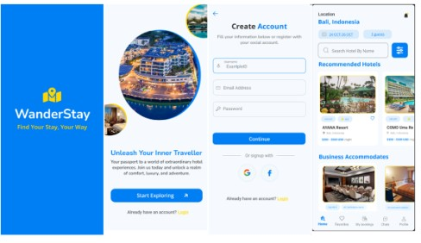

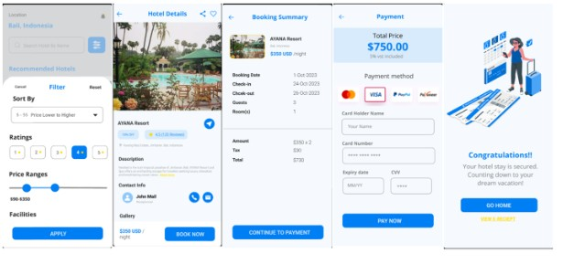

Prototype: -

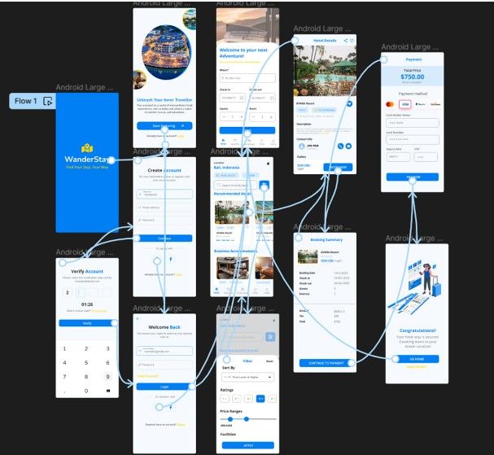

**Result: -**

Hence the localization features can be integrated into a mobile app is created and executed successfully